Project RAG
Muhammad Hafizh Hakim
24523062
SJK - A

Yang Dikumpulkan
• Link GitHub WebApp
- https://github.com/Huapiz/Project-RAG/tree/6b24a73698d8d2c75b15403195ac239901295fec/WebApp
• Link GitHub workflow
- https://github.com/Huapiz/Project-RAG/tree/6b24a73698d8d2c75b15403195ac239901295fec/Workflow%202
• Screenshot WebApp lokal memanggil n8n
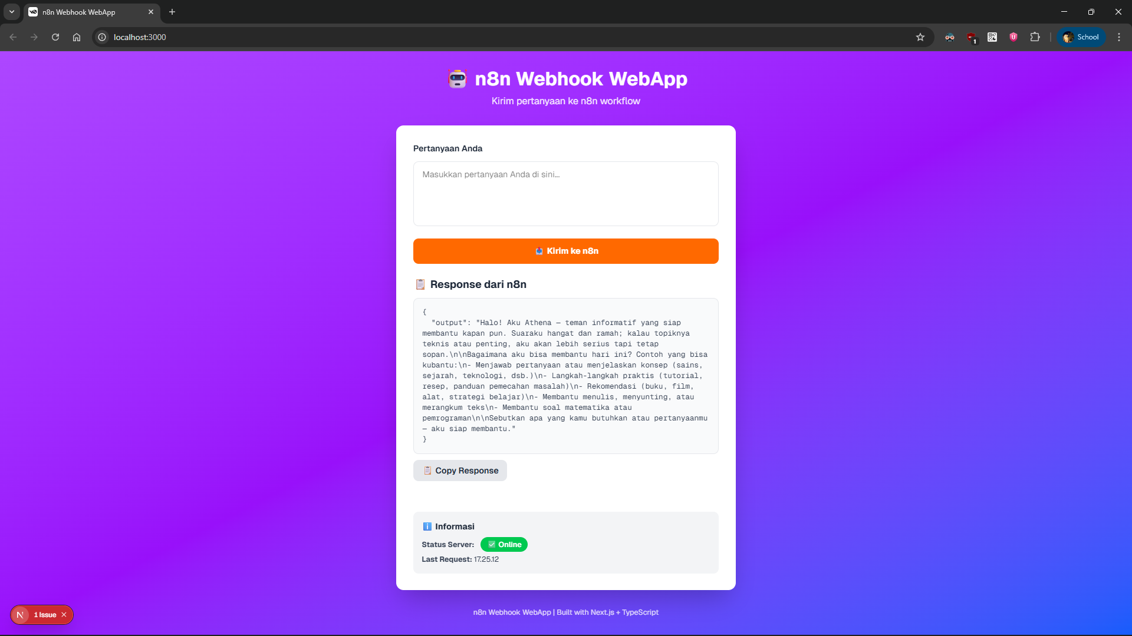
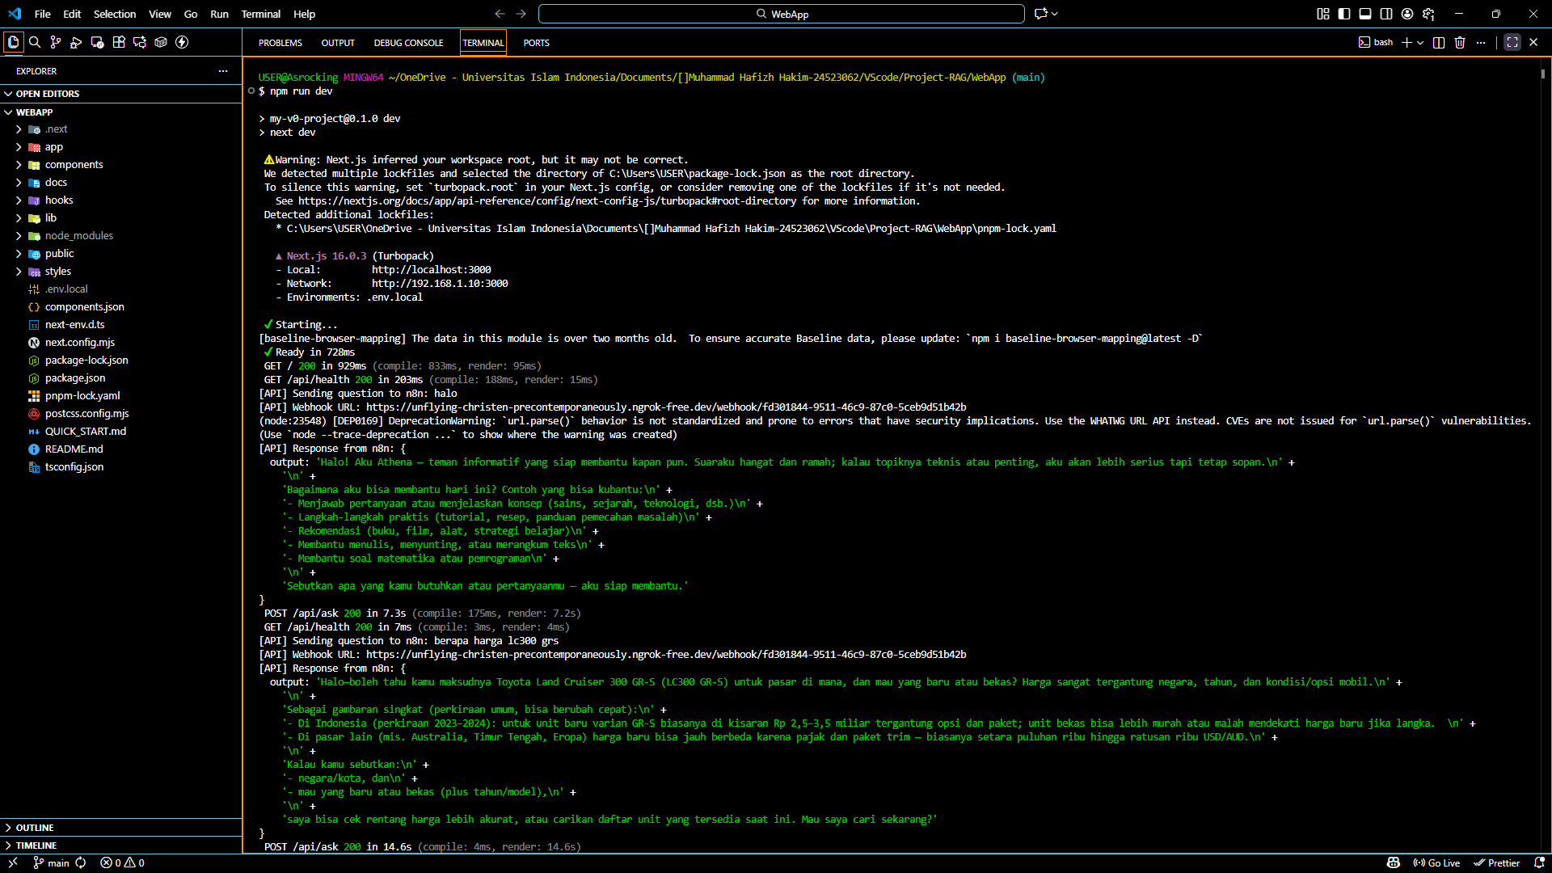
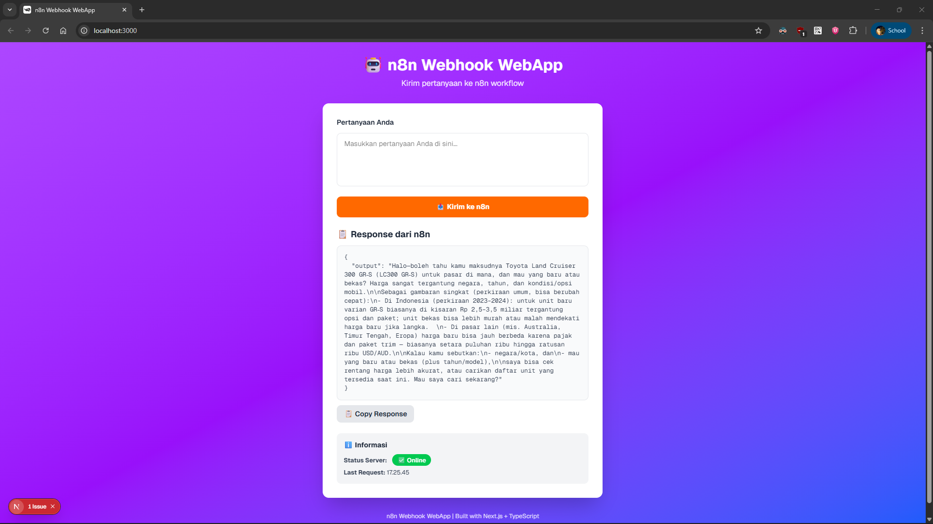
• Penjelasan singkat alur data
- User → WebApp → n8n Workflow → OpenAI (atau logic lain) → Response → User lihat hasilnya
- Input: User mengisi text di textarea dan mengirimkan
- Process: Next.js API route forward ke n8n webhook
- Output: n8n workflow process dan return response
- Display: Hasil ditampilkan formatted di frontend

